Talbott CumberlandPresbyterian Church

**“Together Calling People to Christ”**

7410 W. Andrew Johnson Hwy.

P.O. Box 116, Talbott, TN 37877

Phone and Fax: 865-475-1221

Email:talbottchurch@bellsouth.net

http://www.talbottcpc.org

Drs. Mark & Karen Borchert, Co-Ministers

Lonnie Knight, Music Director/Organist

**The Fifth Sunday of Easter**

**May 19, 2019**

**Morning Worship 11:00 AM**



**GOD GATHERS HIS PEOPLE**

**Interlude** Carolyn McClane, pianist

**Welcome and Announcements** Dr. Karen Borchert, Worship Leader

**Ringing of the Chimes**

*The sounding of the chimes, representing God the Father, Son, and Holy Spirit, is an invitation to prepare for worship through this time of silent reflection and meditation.*

**Prelude**  Franz J. Haydn

“The Heavens Are Telling”

**Bringing of the Light** Emily Rollins, acolyte

Bryson Rose, crucifer

**THE WORSHIP OF GOD**

**\*Call to Worship**

One: We gather today, in the name of the One who is the Alpha and Omega, the First and Last.

**All: We gather today, in the name of the One who gives all the opportunity for repentance that leads to life.**

One:   We gather today, in the name of the One whose command created all things.

**All: We gather today, in the name of the One whose glory is far above earth and heaven.**

One:   We gather today, in the name of the One who will make all things new.

**All:   Lord, make us new.**

* **Hymn of Praise No. 674** Promised Land

“On Jordan’s Stormy Banks I Stand”

**\*Affirmation of Faith**

One: Christians, what do we believe as Cumberland Presbyterians?

**All: We believe in God, the Father Almighty, creator of heaven and**

**earth, and in Jesus Christ, His only Son, our Lord; who was**

**conceived by the Holy Spirit, born of the Virgin Mary,**

**suffered under Pontius Pilate, was crucified, dead and buried;**

**He descended to the grave. The third day He arose from the**

**dead. He ascended into heaven, where He shall sit at the right**

**hand of God the Father Almighty; from where He shall judge**

**the living and the dead. We believe in the Holy Spirit, the holy**

**universal church, the communion of saints; the forgiveness of**

**sins, the resurrection of the body, and the everlasting life.**

**Amen.**

**\*Gloria Patri** Greatorex

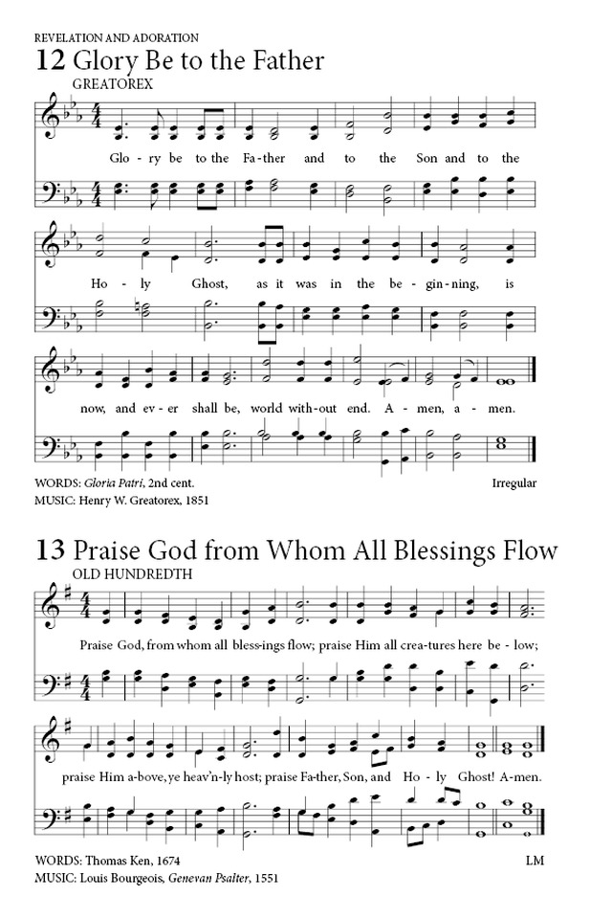

**Prayers of the People**

**The Lord’s Prayer** (In Unison)

Our Father which art in heaven, hallowed be thy name. Thy kingdom come, thy will be done on earth as it is in heaven. Give us this day our daily bread and forgive us our debts, as we forgive our debtors. And lead us not into temptation, but deliver us from evil, for thine is the kingdom, and the power, and the glory, forever. Amen.

**Musical Response No. 629** (Choir & Congregation)

Lord, listen to your children praying,

Lord, send your Spirit in this place;

Lord, listen to your children praying,

send us love, send us power, send us grace.

**Assurance of Pardon** I John 1:9

If we confess our sins, God is faithful and just and will forgive us our sins and cleanse us from all unrighteousness. Brothers and sisters, in Jesus Christ your sins are forgiven.

**OUR WORSHIP THROUGH GIVING**

**Offertory**  Jennifer Finley, pianist

**\*The Doxology**  Old Hundredth

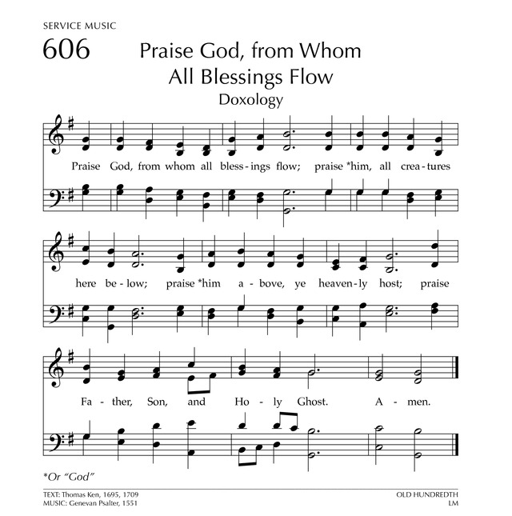

\***Prayer of Dedication and Thanksgiving** Marianne Sharp

**PRESENTATION OF GOD’S WORD**

**Anthem**  arr. Lloyd Larson

“Christians, Celebrate and Sing!”

Rejoice! Rejoice! Rejoice, give thanks and sing!

Christians, celebrate and sing! Lift your voices, let them ring!

Jesus lives! O praise the King! Allelu, alleluia!

The King of Glory lives today. Heaven and earth, rejoice and say: “Alleluia, alleluia! The Lord of Life, the truth and way!”

Christians, celebrate and sing! Lift your voices, let them ring!

Jesus lives! O praise the King! Allelu, alleluia!

Rejoice! Rejoice! Rejoice, give thanks and sing!

Alleluia, alleluia!

**Children’s Message** Marianne Sharp

**\*Hymn Of The Word No. 677** Crouch

“Soon And Very Soon”

**Recognition of Michael Eldridge**

**The Reading Of The Word**

**Old Testament Lesson**  Psalm 148:1-5

Praise the Lord! Praise the Lord from the heavens! Praise Him on high! **2**Praise Him, all His angels! Praise Him, all His army! **3**Praise Him, sun and moon! Praise Him, all you shining stars! **4**Praise Him, you highest heavens, and you waters above the heavens! **5**Let them praise the name of the Lord! For He spoke and they came into being.

**New Testament Lesson** Revelation 21:1-6

Then I saw a new heaven and a new earth. The first heaven and the first earth had passed away. There was no more sea. **2**I saw the Holy City, the new Jerusalem. It was coming down out of heaven from God. It was made ready like a bride is made ready for her husband. **3**I heard a loud voice coming from heaven. It said, “See! God’s home is with men. He will live with them. They will be His people. God Himself will be with them. He will be their God. **4**God will take away all their tears. There will be no more death or sorrow or crying or pain. All the old things have passed away.” **5**Then the One sitting on the throne said, “See! I am making all things new. Write, for these words are true and faithful.” **6**Then He said to me, “These things have happened! I am the First and the Last. I am the beginning and the end. To anyone who is thirsty, I will give the water of life. It is a free gift. [2 Corinthians 13:11](http://www.biblegateway.com/passage/?search=2+Corinthians+13%3A11-13&version=NIV#en-NIV-29055) : [1Th 4:1; 2Th 3:1](http://www.biblegateway.com/passage/?search=1Thess%204:1,%202Thess%203:1&version=NIV)

1. [2 Corinthians 13:11](http://www.biblegateway.com/passage/?search=2+Corinthians+13%3A11-13&version=NIV#en-NIV-29055) : [S Mk 9:50](http://www.biblegateway.com/passage/?search=Mark%209:50&version=NIV)
2. [2 Corinthians 13:11](http://www.biblegateway.com/passage/?search=2+Corinthians+13%3A11-13&version=NIV#en-NIV-29055) : [1Jn 4:16](http://www.biblegateway.com/passage/?search=1John%204:16&version=NIV)
3. [2 Corinthians 13:11](http://www.biblegateway.com/passage/?search=2+Corinthians+13%3A11-13&version=NIV#en-NIV-29055) : [S Ro 15:33; Eph 6:23](http://www.biblegateway.com/passage/?search=Rom%2015:33,%20Eph%206:23&version=NIV)
4. [2 Corinthians 13:12](http://www.biblegateway.com/passage/?search=2+Corinthians+13%3A11-13&version=NIV#en-NIV-29056) : [S Ro 16:16](http://www.biblegateway.com/passage/?search=Rom%2016:16&version=NIV)
5. [2 Corinthians 13:13](http://www.biblegateway.com/passage/?search=2+Corinthians+13%3A11-13&version=NIV#en-NIV-29057) : [Php 4:22](http://www.biblegateway.com/passage/?search=Phil%204:22&version=NIV)

**\*Gospel** John 13:31-35

**31**After Judas went out, Jesus said, “The Son of Man is now honored and God has been honored in Him. **32**If God is honored in Him, God will also honor Him in Himself right now. **33**Little children, I will be with you only a little while. You will look for Me. I say to you what I said to the Jews, ‘Where I am going, you cannot come!’ **34**I give you a new Law. You are to love each other. You must love each other as I have loved you. **35**If you love each other, all men will know you are My followers.”

Leader: This is the Word of God for the people of God.

**People: Thanks be to God.**

[Luke 19:1](http://www.biblegateway.com/passage/?search=Luke%2019:1-9&version=NIV#en-NIV-25733) : [Lk 18:35](http://www.biblegateway.com/passage/?search=Luke%2018:35&version=NIV)

1. [Luke 19:4](http://www.biblegateway.com/passage/?search=Luke%2019:1-9&version=NIV#en-NIV-25736) : [1Ki 10:27; 1Ch 27:28; Isa 9:10](http://www.biblegateway.com/passage/?search=1Kgs%2010:27,%201Chr%2027:28,%20Isa%209:10&version=NIV)
2. [Luke 19:4](http://www.biblegateway.com/passage/?search=Luke%2019:1-9&version=NIV#en-NIV-25736) : [Lk 18:37](http://www.biblegateway.com/passage/?search=Luke%2018:37&version=NIV)
3. [Luke 19:7](http://www.biblegateway.com/passage/?search=Luke%2019:1-9&version=NIV#en-NIV-25739) : [S Mt 9:11](http://www.biblegateway.com/passage/?search=Matt%209:11&version=NIV)
4. [Luke 19:8](http://www.biblegateway.com/passage/?search=Luke%2019:1-9&version=NIV#en-NIV-25740) : [S Lk 7:13](http://www.biblegateway.com/passage/?search=Luke%207:13&version=NIV)
5. [Luke 19:8](http://www.biblegateway.com/passage/?search=Luke%2019:1-9&version=NIV#en-NIV-25740) : [Lk 3:12, 13](http://www.biblegateway.com/passage/?search=Luke%203:12,%20Luke%203:13&version=NIV)
6. [Luke 19:8](http://www.biblegateway.com/passage/?search=Luke%2019:1-9&version=NIV#en-NIV-25740) : [Ex 22:1; Lev 6:4, 5; Nu 5:7; 2Sa 12:6; Eze 33:14, 15](http://www.biblegateway.com/passage/?search=Exod%2022:1,%20Lev%206:4,%20Lev%206:5,%20Num%205:7,%202Sam%2012:6,%20Ezek%2033:14,%20Ezek%2033:15&version=NIV)
7. [Luke 19:9](http://www.biblegateway.com/passage/?search=Luke%2019:1-9&version=NIV#en-NIV-25741) : [S Lk 3:8](http://www.biblegateway.com/passage/?search=Luke%203:8&version=NIV)

**Prayer of the Word**

**Homily** Dr. Mark Borchert

“Heaven on Earth”

**GOD SENDS HIS PEOPLE INTO THE WORLD**

**\*Hymn No. 679** Heaven

“When We All Get To Heaven”

**\*Benediction**

**\*Taking The Light Into The World**

**\*Postlude** “Jerusalem, My Happy Home” Land of Rest

**\***Congregation will please stand if able

** Church Copyright License # 2649243

**EASTERTIDE** (White) The Great Fifty Days, beginning on Easter Day, the festival of Christ’s resurrection; Ascension Day, forty days after Easter, is celebrated to affirm that Jesus Christ is Lord of all times and places.

**Birthdays Anniversaries**

5/22 Nila Lamb 5/22 Matt & Jennifer Finley

5/22 Terry Sanders

5/25 Mackenley Snowden

5/29 Phyllis Knight

**In order to meet the projected General Fund Budget for 2019, ($104,218.00) we need a weekly offering of $2004.00.**

**May 12, 2019**

Sunday School Attendance----21 Sunday School Offering---------$11.00

Morning Worship Attendance-56 Morning Worship Offering-$1210.00

Building Fund Offering--------$90.00

**Total Offering---------------$1311.00**

Thanks for donations given to the Building Fund ***in memory of Mildred Moore*** (sister of Gereldean Carmichael) by Cassie Slabbekorn; ***in memory of Louise Webb*** (daughter of Alice Ogle) by Susan Griggs, Peggy Long, and Norma Stanbery.



**Thursday, May 23, 6:00pm**



**THIS WEEK**

Today May 19 9:30am Prayer Time in the Sanctuary

10:00am Sunday School (for all ages)

11:00am Morning Worship, The Fifth Sunday of Easter

5:30pm Session Meeting

7:00pm Bible Study - Armor of God

Tues. May 21 7:00pm Worship at LifeCare in Jefferson City

Wed. May 22 6:00pm Meal

6:45pm Bible Study - Armor of God

7:15pm Choir Rehearsal

Thurs. May 23 6:00pm Ladies Night Out

**LOOKING AHEAD**

Sun. May 26 9:30am Prayer Time in the Sanctuary

10:00am Sunday School (for all ages)

11:00am Morning Worship, The Sixth Sunday of Easter

6:00pm Family Night

Mon. May 27 MEMORIAL DAY

Wed. May 29 6:00pm Meal

6:45pm Bible Study - Armor of God

7:15pm Choir Rehearsal



**Elders**

|  |  |  |
| --- | --- | --- |
| **Class of 2019** | **Class of 2020** | **Class of 2021** |
| Richard Snowden | Larry Knoll | Terry Sanders |
| Allen Williamson | Jeanie Saunders | Lonnie Knight |

**Deacons**

|  |  |  |
| --- | --- | --- |
| **Class of 2019** | **Class of 2020** | **Class of 2021** |
| Peggy Long | Gale Knoll | Jim Rolen | |

**MAY**

**Elder of the Month**………………………………………Lonnie Knight

**Deacon of the Month**………………………………...………Gale Knoll

**Greeter of the Month**……………….……………..………Susan Griggs



**PRAYER CORNER**

Please be in prayer for graduates in our church and community as they move into the exciting new future God has for each of them.  Also pray for safety as children begin their summer activities away from the routine of school.  
  
  
Please continue to pray for the family of ***Joyce Louise Webb***, the daughter of ***Alice Ogle***.  The family will receive friends 5-7 p.m. on Friday, May 24, 2019 with a memorial service following at 7 p.m. at Atchley Funeral Home in Sevierville, Tennessee. Committal service will be 10 a.m. Saturday, May 25 in Shiloh Cemetery.  
  
  
Please find an extended prayer list in the narthex for your daily prayers and join one of the ministers in prayer for each person on the list at 9:30 on Sunday mornings in the sanctuary.