Talbott CumberlandPresbyterian Church
“Together Calling People to Christ”
7410 W. Andrew Johnson Hwy.
P.O. Box 116, Talbott, TN 37877
Phone and Fax: 865-475-1221
Email:talbottchurch@bellsouth.net
http://www.talbottcpc.org

Drs. Mark & Karen Borchert, Co-Ministers
Lonnie Knight, Music Director/Organist

The Ascension Of The Lord
Holy Communion
June 2, 2019
Morning Worship 11:00 AM

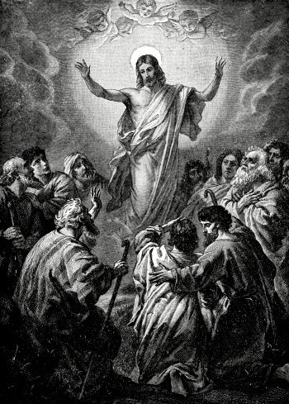

GOD GATHERS HIS PEOPLE

Interlude Carolyn McClane, pianist

Welcome and Announcements Dr. Karen Borchert, Worship Leader

Ringing of the Chimes
The sounding of the chimes, representing God the Father, Son, and Holy Spirit, is an invitation to prepare for worship through this time of silent reflection and meditation.

Prelude Van Denman Thompson
“Fanfare”

Bringing of the Light Emily Rollins, acolyte
Bryson Rose, crucifer

THE WORSHIP OF GOD

*Call to Worship
One: Christ has ascended, and we proclaim that Christ is coming again in glory.
All: Come, Lord Jesus, come!
One: Christ says, “I am the Alpha and the Omega.”
All: “I am the first and the last, the beginning and the end.”
One: “I am the offspring of David.”
All: “I am the bright morning star.
One: Whoever is thirsty may come.
All: Whoever longs for mercy may come.
One: Jesus Christ is coming again.
All: Come, Lord Jesus, come!
*Hymn of Praise No. 258 Llainfair
“Hail The Day That Sees Him Rise”

*Affirmation of Faith
One: Christians, what do we believe as Cumberland Presbyterians?
All: We believe in God, the Father Almighty, creator of heaven and
earth, and in Jesus Christ, His only Son, our Lord; who was
conceived by the Holy Spirit, born of the Virgin Mary,
suffered under Pontius Pilate, was crucified, dead and buried;
He descended to the grave. The third day He arose from the
dead. He ascended into heaven, where He shall sit at the right
hand of God the Father Almighty; from where He shall judge
the living and the dead. We believe in the Holy Spirit, the holy
universal church, the communion of saints; the forgiveness of
sins, the resurrection of the body, and the everlasting life.
Amen.

*Gloria Patri Greatorex
Prayers of the People

The Lord’s Prayer (In Unison)
Our Father which art in heaven, hallowed be thy name. Thy kingdom come, thy will be done on earth as it is in heaven. Give us this day our daily bread and forgive us our debts, as we forgive our debtors. And lead us not into temptation, but deliver us from evil, for thine is the kingdom, and the power, and the glory, forever. Amen.

Musical Response No. 629 (Choir & Congregation)
Lord, listen to your children praying,
Lord, send your Spirit in this place;
Lord, listen to your children praying,
send us love, send us power, send us grace.

Assurance of Pardon I John 1:9
If we confess our sins, God is faithful and just and will forgive us our sins and cleanse us from all unrighteousness. Brothers and sisters, in Jesus Christ your sins are forgiven.

OUR WORSHIP THROUGH GIVING

Offertory Charles Demorest
“Andante Religioso”

*The Doxology Old Hundredth
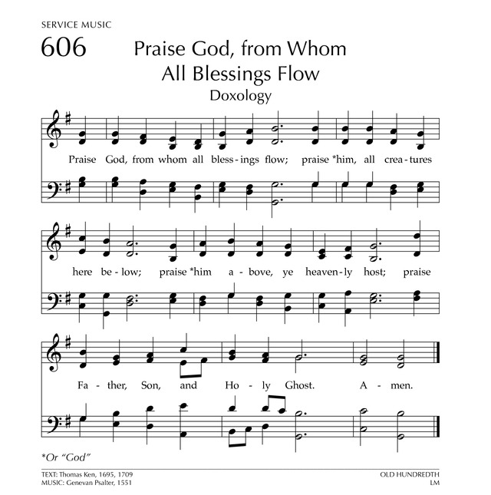

*Prayer of Dedication and Thanksgiving Gereldean Carmichael

PRESENTATION OF GOD’S WORD

Anthem arr. Kendzia & Warrik-Smith

“Over My Head”
Carole Martin Aversa, soloist & choir

Over my head, I hear music in the air. There must be a God somewhere.

Come and see: he has rolled away the stone.
Over my head, I hear singing in the air.
Come and see: he is risen from the dead.
Over my head, I see Jesus in the air.

The Reading Of The Word

Old Testament Lesson Psalm 97:1, 10-12

The Lord rules. Let the earth be full of joy. Let the many islands be glad. ¹⁰ Let those who love the Lord hate what is bad. For He keeps safe the souls of His faithful ones. He takes them away from the hand of the sinful. ¹¹ Light is spread like seed for those who are right and good, and joy for the pure in heart. ¹² Be glad in the Lord, you who are right and good. Give thanks to His holy name.

New Testament Lesson Acts 16:25-34
²⁵ About midnight Paul and Silas were praying and singing songs of thanks to God. The other men in prison were listening to them. ²⁶ All at once the earth started to shake. The stones under the prison shook and the doors opened. The chains fell off from everyone.
²⁷ The man who watched the prison woke up. He saw the prison doors wide open and thought the men in prison had gotten away. At once he pulled out his sword to kill himself. ²⁸ But Paul called to him, “Do not hurt yourself. We are all here!” ²⁹ The man who watched the prison called for a light. Then he ran in and got down in front of Paul and Silas. He was shaking with fear. ³⁰ As he took them outside, he said, “Sirs, what must I do to be saved?”
³¹ They said, “Put your trust in the Lord Jesus Christ and you and your family will be saved from the punishment of sin.”
³² Then Paul spoke the Word of God to him and his family. ³³ It was late at night, but the man who watched the prison took Paul and Silas in and washed the places on their bodies where they were hurt. Right then he and his family were baptized. ³⁴ He took Paul and Silas to his house and gave them food. He and all his family were full of joy for having put their trust in God.

*Gospel Luke 24:50-53

⁵⁰ Jesus led them out as far as Bethany. Then He lifted up His hands and prayed that good would come to them. ⁵¹ And while He was praying that good would come to them, He went from them (*and was taken up to heaven and ⁵² they worshiped Him). Then they went back to Jerusalem with great joy. ⁵³ They spent all their time in the house of God honoring and giving thanks to God.

Leader: This is the Word of God for the people of God.
People: Thanks be to God.

*Hymn of the Word No. 259 Lasst Uns Erfreuen
“A Hymn Of Glory Let Us Sing”

Children’s Message

Pastoral Prayer

Homily Dr. Mark Borchert
“Disruptive Information”

THE SERVICE OF HOLY COMMUNION

The Institution and Consecration of The Lord’s Supper

The Invitation to the Table
Holy Communion and the Lord’s Table are “open” in that all who come in faith in Christ, regardless of church membership or denomination, are welcome.

The Sharing of the Bread

Musical Response

Let us break bread together on our knees;
let us break bread together on our knees.
When I fall on my knees, with my face to the rising sun,
O Lord, have mercy on me.
The Sharing of the Cup

Musical Response

Let us drink wine together on our knees;
let us drink wine together on our knees.
When I fall on my knees, with my face to the rising sun,
O Lord, have mercy on me.

GOD SENDS HIS PEOPLE INTO THE WORLD

*Hymn No. 262 Darwall
“Rejoice, The Lord Is King”

*Benediction

*Taking The Light Into The World

*Postlude “Voluntary in F” J. Heneger

*Congregation will please stand if able
** Church Copyright License # 2649243

Ascension Day (white) Forty days after Easter, is celebrated to affirm that Jesus Christ is Lord of all times and places.

Birthdays Anniversaries

6/05 Elissa Borchert 6/2 Errin & Sue Ellen Carroll
6/08 Ralph Lamb
6/10 Bryson Rose

In order to meet the projected General Fund Budget for 2019, ($104,218.00) we need a weekly offering of $2004.00.

May 26, 2019

Sunday School Attendance----25 Sunday School Offering---------$24.00
Morning Worship Attendance-52 Morning Worship Offering-$1021.00
Building Fund Offering-------$210.00
Total Offering---------------$1255.00

Thanks for donations given to the Building Fund in memory of Donna Garrett Breeden by Terry & Mitzi Sanders; in memory of Mildred Moore by Edith Quarles, Terry & Mitzi Sanders, and Jane Satterfield; in memory of Louise Webb by Marcella Franklin, Edith Quarles, and Terry & Mitzi Sanders; in memory of Vaughn Stanbery by Norma Stanbery.

THIS WEEK
Today June 2 9:30am Prayer Time in the Sanctuary
10:00am Sunday School (for all ages)
11:00am Morning Worship, Ascension Sunday, Holy
Communion, Food Pantry Sunday
5:30pm Session Meeting - Spiritual Questions: On
Order and Chaos
7:00pm Bible Study
Wed. June 5 6:00pm Meal
6:45pm Bible Study – Spiritual Questions: On Equality
7:15pm Choir Rehearsal

LOOKING AHEAD
Sun. June 9 9:30am Prayer Time in the Sanctuary
10:00am Sunday School (for all ages)
11:00am Morning Worship, Pentecost Sunday
7:00pm Bible Study
Tues. June 11 6:00pm CPWM Meeting
Wed. June 12 6:00pm Meal
6:45pm Bible Study
7:15pm Choir Rehearsal

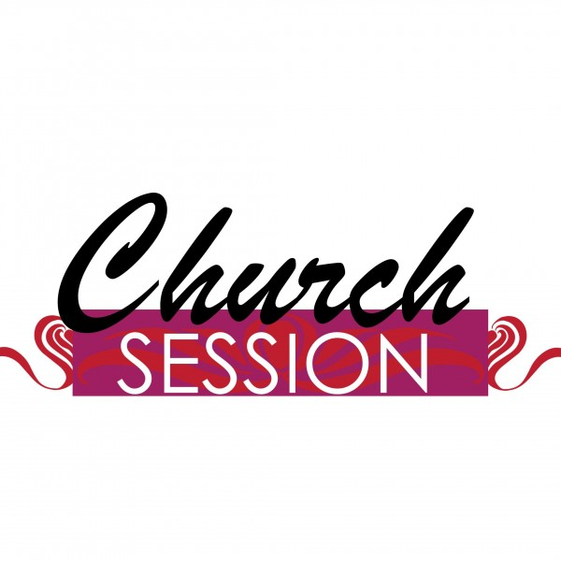
Elders
Class of 2019 | Class of 2020 | Class of 2021
Richard Snowden | Larry Knoll | Terry Sanders
Allen Williamson | Jeanie Saunders | Lonnie Knight
Deacons
Class of 2019 | Class of 2020 | Class of 2021
Peggy Long | Gale Knoll | Jim Rolen

JUNE
Elder of the Month…………………………….……..Richard Snowden
Deacon of the Month………………………………………….Jim Rolen
Greeters of the Month…………….Jane Satterfield & Michael Stanbery

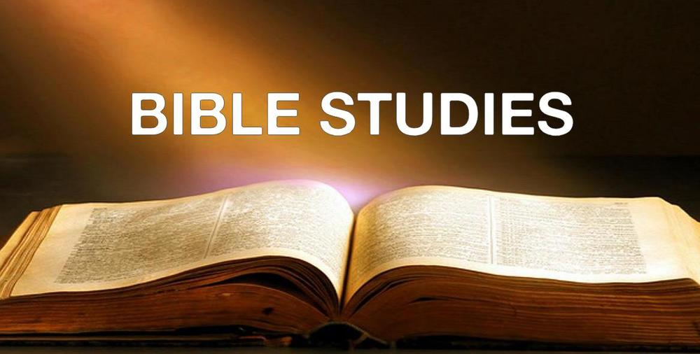

In June, our Bible Studies on Sunday and Wednesday evenings will focus on Spiritual Questions. If you have spiritual questions, place them in the Question Box in the narthex and we will investigate them together at some point in the series.

SERMON QUEST

Disruption One: You are valued for who you are, not ________________

___________________________________________________________.

Disruption Two: You are saved through your faith in Jesus, not ________

___________________________________________________________.

Disruption Three: Faith is never entirely personal, but leads you _______

___________________________________________________________.

PRAYER CORNER

On this Ascension Sunday, let us remember that Christ has left us for the time, but sent the Holy Spirit to be at work in our lives and our church. Let us pray for our church to be active in this world, leading others to Christ.
Please pray for Alice Ogle as the doctors determine the best course of action for her hip and as she faces the loss of her daughter.
Be in prayer for our Session as they meet today to consider the life and mission of our church.
Please find an extended prayer list in the narthex for your daily prayers, and join one of the ministers in prayer for each person on the list and our morning service at 9:30 on Sunday mornings in the sanctuary. Bring your own concerns for prayer at that time.

